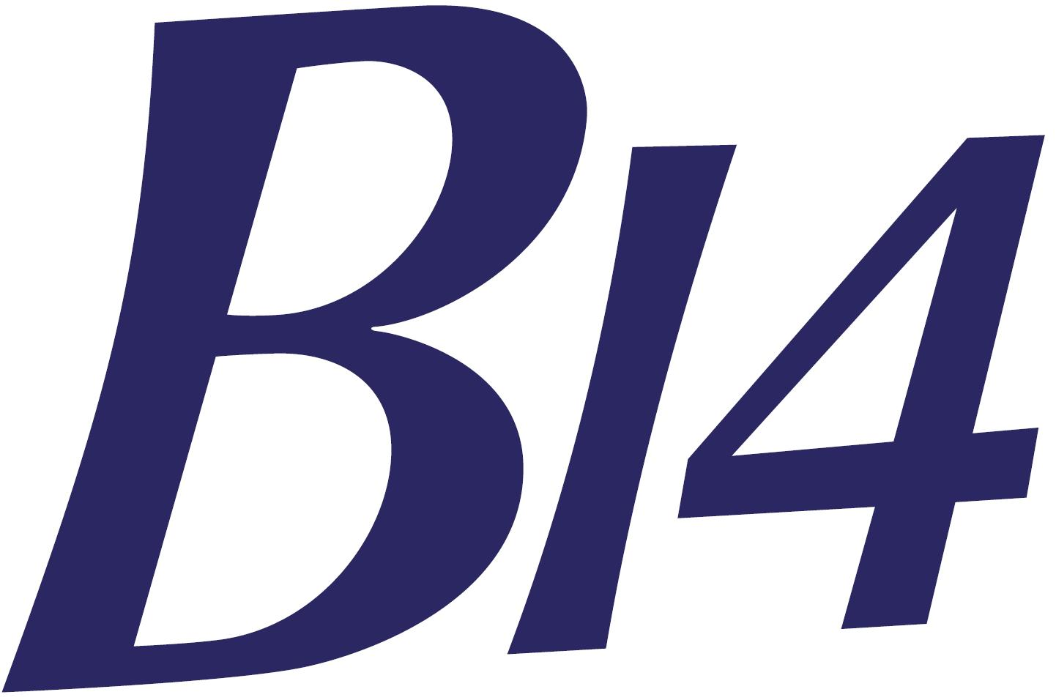 | B14 National and Open Championships  2nd – 5th August 2018  Paignton Sailing Club (PSC) | 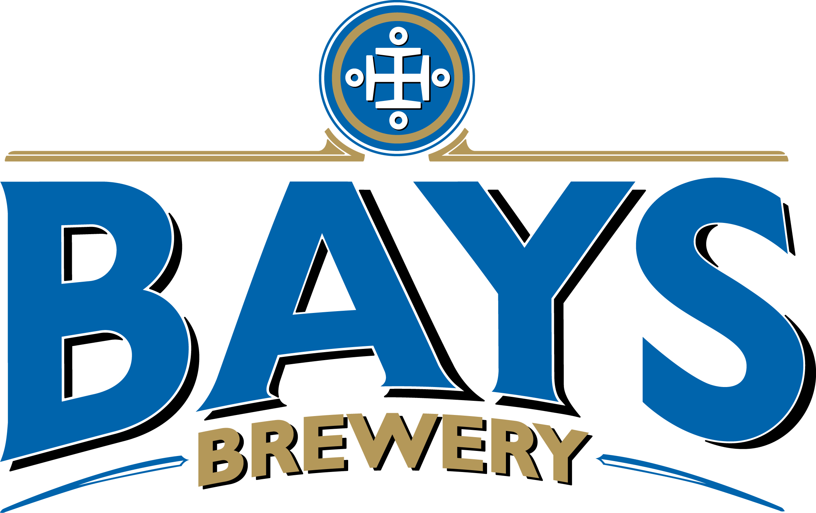

Event Polo Shirts

We have arranged event polo shirts at £16 each. They are available in a variety of colours and sizes both ladies and mens. Please order below by 15th July. Please see below for colours and sizes, ladies or gents.
Ladies or Mens |  |  |  |  | Colour |  |  |  |  |  | Size |  |  |  |  | Number
 |  |  |  |  |  |  |  |  |  |  |  |  |  |  |  |  | £
 |  |  |  |  |  |  |  |  |  |  |  |  |  |  |  |  | £
 |  |  |  |  |  |  |  |  |  |  |  |  |  |  |  |  | £
 |  |  |  |  |  |  |  |  |  |  |  |  |  |  |  |  | £
Total amount payable |  |  |  |  |  |  |  |  |  |  |  |  |  |  |  |  | £

Please email your completed form to:

Tony Blackmore – tony@sailsport.plus.com - 07977 512673

And transfer your polo shirt fee via bacs to:

B14 Class Assoc at sort code 20 05 06 acc. 8072 8020 quoting surname and sail no.

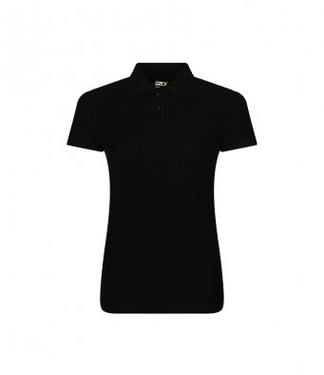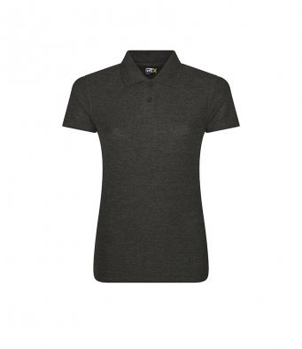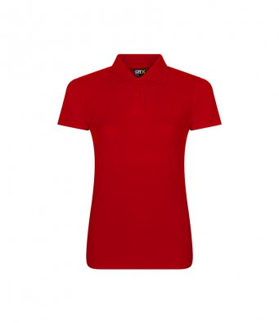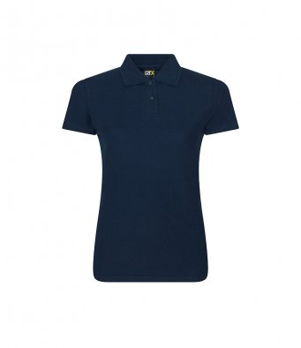

Black Charcoal Red Navy

Size: | XS | S | M | L | XL | XXL | 3XL | 4XL
Ladies size: | 8 | 10 | 12 | 14 | 16 | 18 | 20 | 22

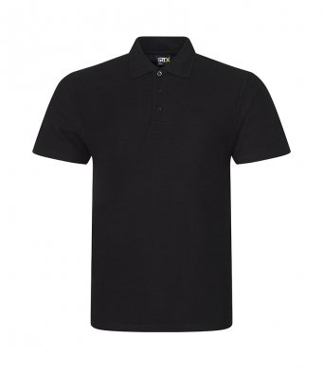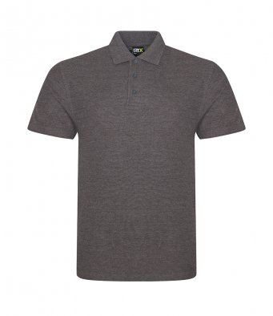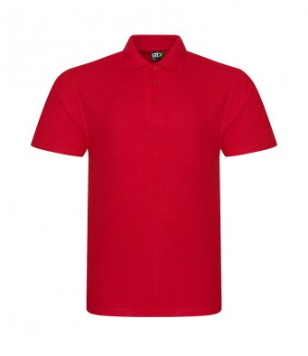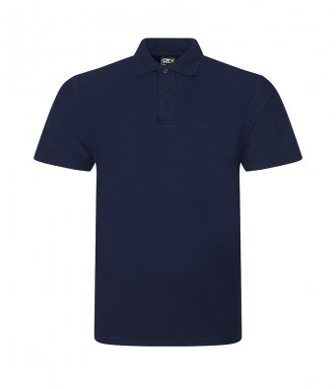

Black Charcoal Red Navy
 | Size: | XS | S | M |  | L | XL | XXL | 3XL | 4XL |  | 5XL | 6XL | 7XL
 | Chest (to fit): | 32 | 34 | 38 |  | 42 | 46 | 50 | 53 | 56 |  | 59 | 62 | 65

