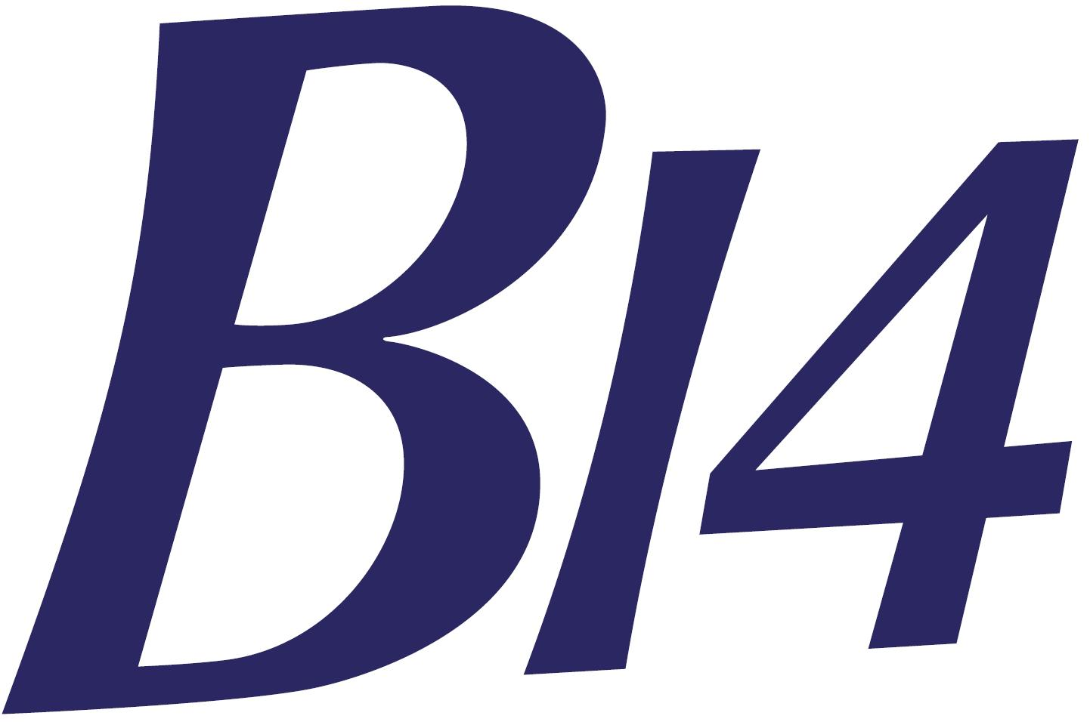 |   WHITSTABLE YACHT CLUB  B14 GUL Open Meeting 1st – 2nd June 2019 | 

SAILING INSTRUCTIONS

DEFINITION
The ‘Organising Authority’ is defined as Whitstable Yacht Club as the event host and the B14 Class Association.
1. RULES
The event shall be governed by the rules as defined in The Racing Rules of Sailing 2017-2020 (RRS), the prescriptions of the RYA, the Rules of the B14 Class Association except if changed by the Notice of Race or these Sailing Instructions. In the event of a conflict between any of the aforementioned documents, these Sailing Instructions shall prevail. This changes rule 63.7.
2. NOTICES TO COMPETITORS
Notices to competitors will be posted on the official notice board, located in the Club House.
3. CHANGES TO SAILING INSTRUCTIONS
Any change to the Sailing Instructions will be posted before 1030 on the day it will take effect, except that any change to the Schedule of Races will be posted by 2000 on the day before it will take effect.
4. SIGNALS MADE ASHORE
4.1. All signals made ashore will be displayed on the clubhouse mast.
4.2. When the Race Committee wishes the fleet to remain on-shore, the Answering Pennant shall be displayed with 2 sound signals. The Answering Pennant shall be lowered with one sound signal to signify that the fleet should proceed to the course area. No Warning Signal shall be made until at least 45-minutes have elapsed from the lowering of the Answering Pennant.
5. FORMAT OF RACES
The regatta will consist of a single series.
6. SCHEDULE OF RACES
6.1. Dates of Racing: 1st and 2nd June 2019.
6.2. Times of Briefings and 1st Warning Signals:
Saturday: Briefing 1100 hrs, racing (Races 1, 2, 3) 1225 hrs
Sunday: Racing (Races 4, 5, 6) 1055 hrs
6.3. No more than 4 races per day will be sailed
6.4. On the last day of the regatta no warning signal will be made after 1600 hrs.
7. CLASS FLAGS
The Class Flag will be the “GUL” sponsors flag
8. RACING AREA
Courses will be set in Whitstable Bay, approximately North West of Whitstable Yacht Club.

9. THE COURSE
9.1. See Appendix A
9.2. The approximate magnetic compass bearing from the Committee Boat to Mark 1 may be displayed on the side of the Committee Boat.
10. MARKS
10.1. Marks are described in Appendix A.
11. THE START
11.1. The start line will be between the Committee boat’s mast displaying an orange flag and pin end black buoy.
11.2. A boat starting later than 5 minutes after her starting signal shall be scored Did Not Start without a hearing. This changes rules A4 and A5.
11.3. Start and finish boats may hold position by using engines.
12. CHANGE OF POSITION OF THE NEXT MARK
Rule 33 does not apply as any change of position of the next mark is implemented with the alternating windward marks.
13. THE FINISH
The finish line will be between the Committee boat’s mast displaying a blue flag and black buoy. If the course is to be shortened at Mark 1, proceed to Mark 2 and then straight to the finish. The course will not be shortened at any mark other than the Finish Mark or Mark 1.
14. PENALTY SYSTEM
14.1. Rule 44.1 is changed so that the Two-Turns Penalty is replaced by the One-Turn Penalty.
14.2. When an incident occurs where a penalty applies while the head of the spinnaker is above the main-boom gooseneck, the penalty may be taken immediately after the next time the head of the spinnaker is lowered below the main-boom gooseneck, but shall always be taken prior to rounding the next mark or crossing the finishing line. This changes rule 44.2.
14.3. Touching a mark (other than a starting or finishing line mark) with any part of the boat or crew shall not constitute an infringement of the Rules. Manhandling a mark which results in an advantage is not allowed and a boat so doing shall promptly retire. If a boat touches a start or finish mark they shall complete a one-turn penalty as described in RRS 44.2. This changes RRS 31.
15. TIME LIMITS AND TARGET TIMES
15.1. Time limits and target times for the lead boat are as follows:
Time limit 75 min Target Time 55 min
Failure to meet the target time will not be grounds for redress. This changes rule 62.1(a)
15.2. Boats failing to finish within 20 minutes after the first boat sails the course and finishes will be scored according to their observed position on the course, which may be the position at the last mark rounded. This changes rules 35, A4 and A5
15.3 The race committee may take the decision to finish boats that are one or close to one lap down on the leaders early, so pealing the boats off the course to the finish. This will be instructed by a rib at the windward mark. If used, this will supersede 15.2

16. PROTESTS AND REQUESTS FOR REDRESS
16.1. Protest forms are available at the race office, located in the clubhouse. Protests and requests for redress or reopening shall be delivered there within the appropriate time limit.
16.2. The protest time limit is 1 hour after the last boat has finished the last race of the day. The same time limit applies to protests by the race committee and protest committee about incidents they observe in the racing area and to requests for redress. This changes RRS Rules 61.3 and 62.2.
The time limit may be extended at the discretion of the Race Committee.
16.3. Notices will be posted no later than 30 minutes after the protest time limit to inform competitors of hearings in which they are parties or named as witnesses.
16.4. Notices of boats protested by the race committee or protest committee will be posted to inform boats under rule 61.1(b).
16.5. Breaches of instructions 18, 21, 22 or 23 will not be grounds for protest by another boat. This changes rule 60.1(a). Penalties for these breaches may be less than disqualification if the Protest Committee so decides.
16.6. On the last scheduled day of racing a request for reopening a hearing shall be delivered:
(a) Within the protest time limit if the requesting party was informed of the decision on the previous day.
(b) No later than 30 minutes after the requesting party was informed of the decision on that day. This changes rule 66.
16.7. On the last scheduled day of racing a request for redress from a protest committee decision shall be delivered no later than 30 minutes after the decision was posted. This changes rule 62.2.
17. SCORING
17.1. 3 races are required to be completed to constitute a series.
17.2.
(a) When fewer than 4 races have been completed, a boat’s series score will be the total of her race scores.
(b) When from 4 to 6 races have been completed, a boat’s series score will be the total of her race scores excluding her worst score.
18. SAFETY REGULATIONS
18.1. A boat that retires from a race shall notify the race committee before leaving the race area.
18.2. All crews must wear personal flotation devices while afloat. Wet suits and dry suits are not personal flotation devices. Flag Y will not be displayed. This changes rule 40.
18.3. Each boat is required to ‘tally’ on before going afloat and ‘tally’ off once returned to shore. The tally board will be located by the veranda entrance from the sea wall. The penalty for failure to comply with this instruction will be 5 points added to the boat’s series score for each infringement, without a hearing. A list of boats that have infringed will be posted on the official notice board before the protest time limit. This changes rule 63.1.
19. REPLACEMENT OF CREW OR EQUIPMENT
19.1. Substitution of competitors will not be allowed without prior written approval of the Race Committee.
19.2. Substitution of damaged or lost equipment will not be allowed unless authorised by the Race Committee. Requests for substitution shall be made to the committee at the first reasonable opportunity.
19.3 Distinguishing Numbers – at its sole discretion the Race Committee may on receipt of a written request permit a boat to use sails carrying a distinguishing number other than that required by RRS Appendix G1.1(c). This changes RRS Rule 77.
Under no circumstances shall a boat be permitted to use the sail number of another boat already competing in the event.
20. EQUIPMENT AND MEASUREMENT CHECKS
A boat or equipment may be inspected at any time for compliance with the class rules and sailing instructions. On the water, a boat can be instructed by a race committee equipment inspector or measurer to proceed immediately to a designated area for inspection.
21. ADVERTISING
Boats shall display advertising as required and supplied by the B14 Class Association.

22. SUPPORT BOATS
22.1. During racing support boats shall remain more than 100 metres from the course area except when asked to assist by the Race Committee.
22.2. Support boats shall be marked with the sail number(s) of the competitor(s) that they support.
23. RUBBISH DISPOSAL
Boats shall not put rubbish in the water. Trash may be placed aboard support and race committee boats.
24. RADIO COMMUNICATION
While on the water, a boat shall not carry equipment capable of making radio transmissions or receiving radio communications, except for equipment provided by the organising authority. This restriction also applies to mobile telephones. This amends Class Rule C.5.1(b)
25. PRIZES
Prizes will be awarded for both Grand Prix and Classic B14s in the event. Further prizes may be awarded dependant on entries.
26. DISCLAIMER OF LIABILITY
Competitors participate in the regatta entirely at their own risk. See rule 4, Decision to Race. The organising authority will not accept any liability for material damage or personal injury or death sustained in conjunction with or prior to, during, or after the regatta.
27. INSURANCE
Each participating boat shall be insured with valid third-party liability insurance with a minimum cover of £3 million per event.
28. RIGHTS TO USE NAME AND LIKENESS
By participating in this event, competitors automatically grant to the organising authority and the event sponsors the right, in perpetuity, to make, use, and show, at their discretion, any photography, audio and video recordings, and other reproductions of them made at the venue or on the water from the time of their arrival at the venue, until their final departure, without compensation.

APPENDIX A

MARKS & COURSE

Mark 1 will be an orange cylindrical pillar buoy.

Mark 2 will be an orange flag.

Marks 3s and 4p will be orange cylindrical pillar buoys.

Order of rounding:
Start: 1, 2, 3s or 4p, 1, 2, 3s or 4p, 1, 2, finish

1
3S
4P

Start and Finish Line
2
WIND

