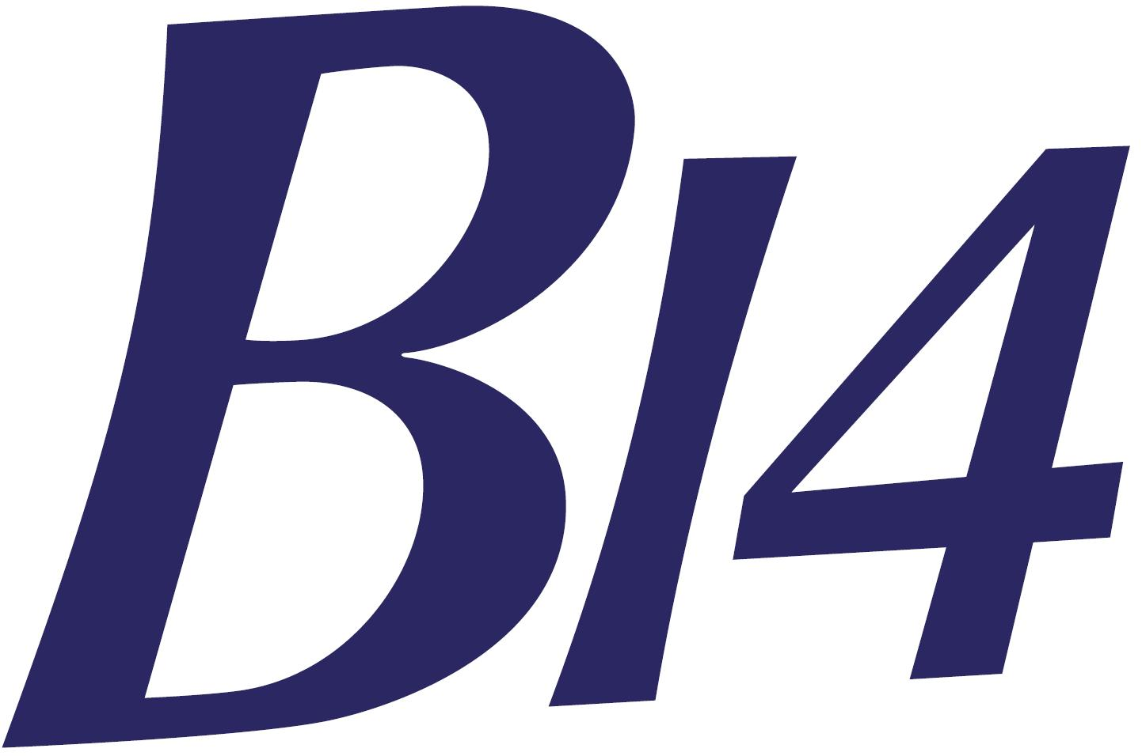 | WHITSTABLE YACHT CLUB  B14 GUL Open Meeting 01st – 02nd June 2019 | 
In association with:
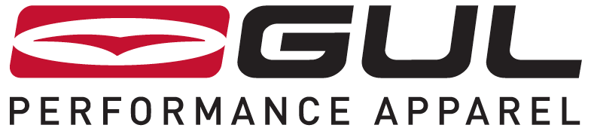

ENTRY FORM

I agree to be bound by the Racing Rules of Sailing 2017 - 2020, by RYA prescriptions, by Class Rules and the WYC Sailing Instructions.

I agree/do not agree that photographs of this boat and crew may be taken and used for publicity purposes.

INSURANCE
Competitors must hold a valid and current certificate of insurance with third party liability cover of at least £3,000,000 whilst racing at Whitstable Yacht Club.

(PLEASE USE BLOCK CAPITALS)

SAIL NO. ________________

BOAT NAME ________________________________________________________

SIGNATURE ___________________________ DATE ____________________

HELMSMAN _________________________ CREW ___________________

OWNER (if different from helm) _______________________________________

OWNERS ADDRESS ________________________________________________

________________________________________________

CLUB _____________________________________________________________

CLASS ASSOCIATION MEMBER: YES / NO (delete one)

TALLY NUMBER: ………

.......................................................................................................................................................
For WYC use only
FEE PAID (£40) _______________________________ (CASH / CHEQUE)

